
Green University of Bangladesh
Department of Computer Science and Engineering (CSE)
Faculty of Sciences and Engineering
Semester: (Fall, Year:2023), B.Sc. in CSE (Day)

Lab Report NO # 06
Course Title: Engineering Drawing
Course Code: CSE-208 Section: 221-D2

Lab Experiment Name: Implementation of 2D floor planning

Student Details

Name |  | ID
1. | Md.Fahad Nakib | 221902149

Lab Date : 20-10-23
Submission Date : 24-10-23
Course Teacher’s Name : Md Naimul Pathan

Lab Report Status
Marks: ………………………………… Signature:.....................
Comments:.............................................. Date:..............................

1. TITLE OF THE LAB EXPERIMENT
Implementation of 2D floor planning
2. OBJECTIVES
- It will help us to gain knowledge about 2D or 3D drawing platform Auto cad and how to use this software.
- We can learn about 2D drawing technique and uses of line, rectangle, circle, etc.
- In this experiment we will implement a provided figure using 2D drawing technique.

3. TOOLS AND TECHNOLOGIES

1. line:
Line command draws a straight line from one point to another.
Shortcut Key: L
2. Circle:
Circle helps us to draw a circle. We can draw circle in many ways like using radius, diameter, tan-tan radius, etc.
Shortcut Key: C
3. Trim:
It is used for cutting unwanted line and edges.
Shortcut Key: Tr
4. Angle:
Angle helps us to draw line using different angle. To implement this first we have to select line then press ‘Shift+@’ and give line diameter then press ‘<’ give angle (45) and then press ‘Enter’.
5. Offset:
Offset helps us to create same line in a particular distance.
6. Home design blocks:
Using this tool we can get some objects like sofa, table, bed, lamp, oven, bath tab, etc.

4. IMPLEMENTATION

Step: 01

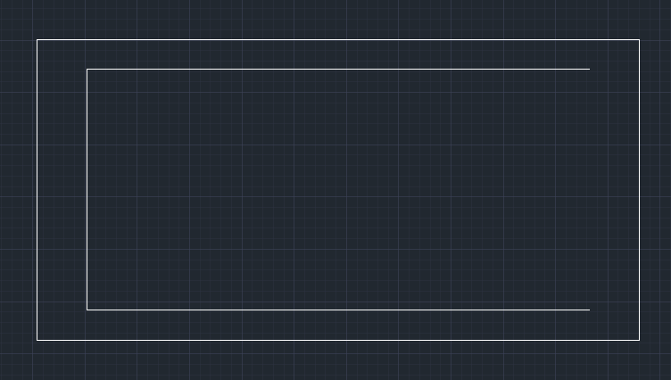

Figure: 01
Step: 02

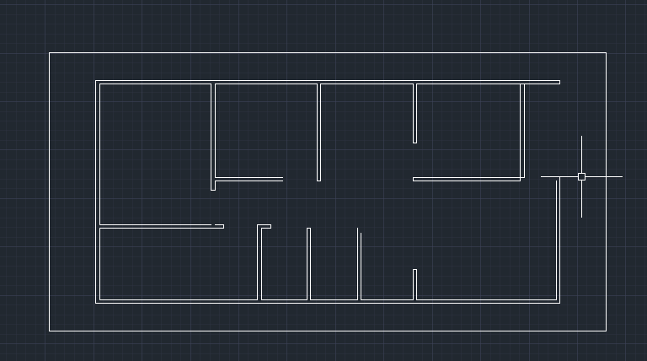

Figure: 02
Step: 03
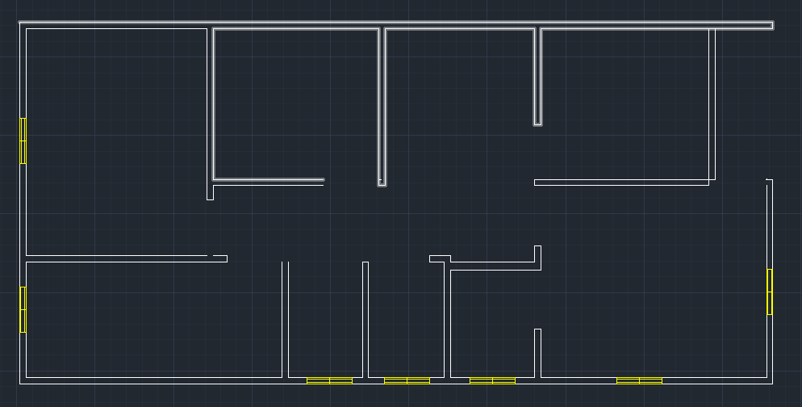
Figure: 03

Step: 04

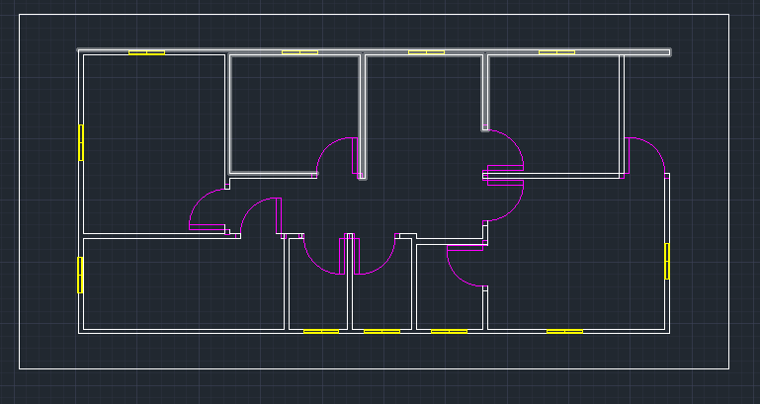

Figure: 04
Step: 05

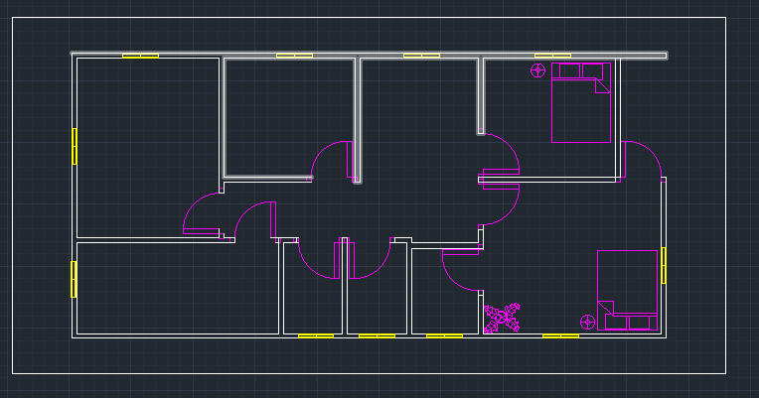
Figure: 05

Step: 06

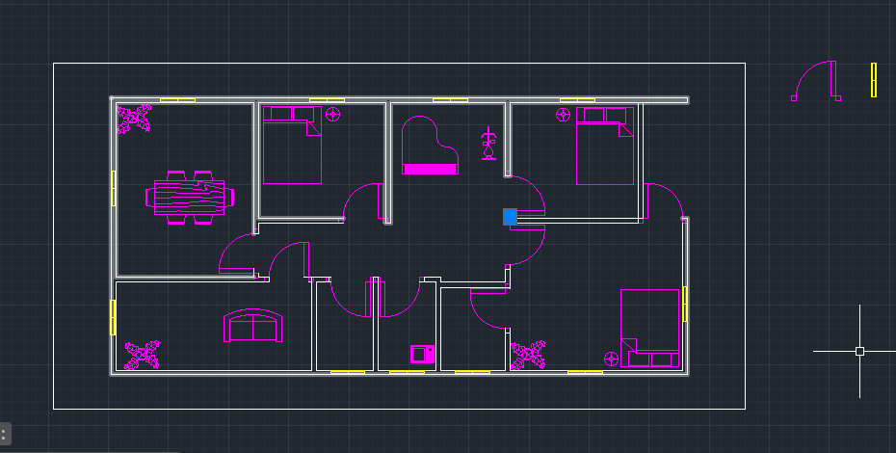

Figure: 06

6. FINAL OUTPUT

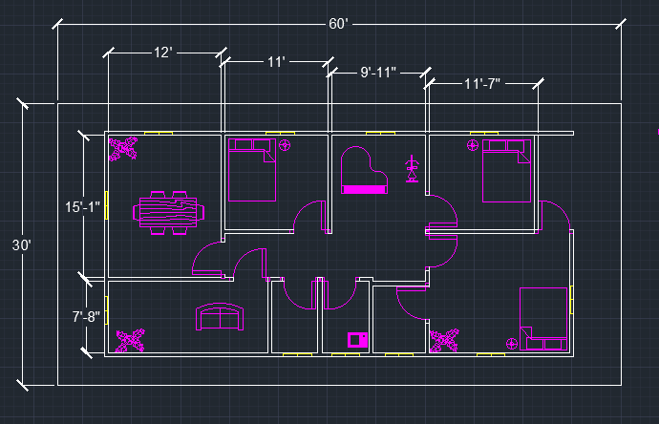

Figure: 08

7. ANALYSIS AND DISCUSSION

- This experiment helps us to learn about basic Auto Cad operations such as create lines, circle, rectangle, blocks, layers, etc.
- By this experiment we obtain the knowledge about 2D Floor design drawing technique and we can implement these tools to implement real life object.
- We have to be careful about while taking the measurement for the hatches. Otherwise it will leads to a wrong diagram.

